Elijah Michaelson
Individual Work
Week 5
This week I set out to do some hands-on neural network tutorials. The first tutorial I went through was to understand how neural networks act as universal function approximators. This tutorial allowed me to play around with manually manipulating the weight between nodes, their configurations, and their bias values. The tutorial provided a visual of how the overall functional mapping of the network changed as I varied these qualities/quantities of the network. I also got a more intuitive understanding of how increasing the number of hidden nodes increased the resolution of my function approximation. Additionally, I learned about how the characteristics at the individual neuronal level affect the approximation. In particular, the activation function of the nodes play an integral role in the function of the network. The sigmoid function is a commonly used function that is applied to the weighted sum of all the connections to a neuron. The sigmoid function performs well because it is a good approximation to the step function, as was visually apparent when I was manually manipulating the network as I described previously. However, there are a number of other functions that are used in the activation function (actually, any function can be used, but some work much better than others):
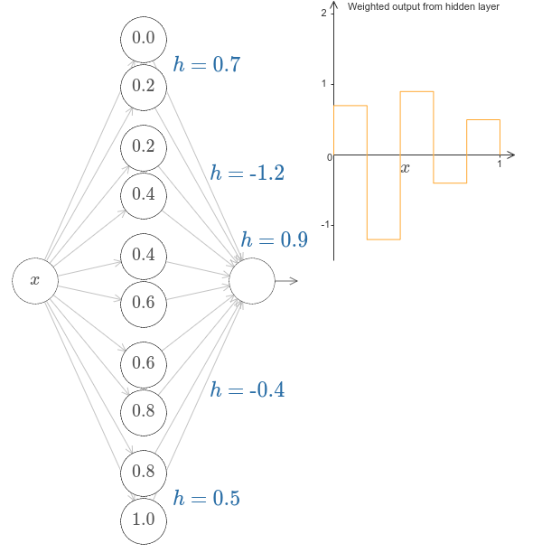
- tanH
- ReLU (Rectified Linear Unit)
- Leaky ReLU
- Logistic
- identity function
- ArcTan
- etc

After getting a better understanding of the inner working of a neural network by going through the interactive tutorial, I next went through a Tensorflow tutorial to actually download one and do some image classification. We plan on using Tensorflow, which is a popular, well-equipped machine learning library. I went through the process of downloading Virtualenv, which is a virtual python environment, activating it, downloading and upgrading Tensorflow, and then launching TensorFlow. I then classified an image of a panda using the classification program from the tutorial, which yielded an 89% classification score.
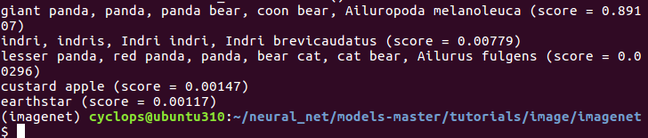
I felt like this week went really well on all fronts. We got together as a team and had a sprint planning meeting which stimulated a lot of good conversation. Additionally, I learned a lot about neural networks and I got my hands dirty with Tensorflow and some image classification.

